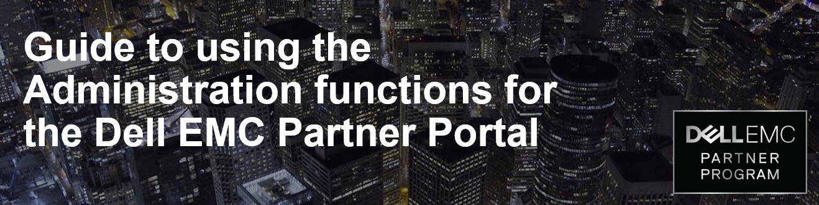
Login to Dell EMC Partner Portal

You can access the Dell EMC Partner portal at www.dellemc.com/partner
Account Settings

Many of the tools used by Account Admins can be found on the Account Settings page.
The Account Settings page makes it easy for admins to add or update information like:
- Add new users
- Update user information
- Enable incentives
- Provision deal registration
- Deactivate users
- Update company information and billing information
- Please note you may not add emails with public domains
There are two routes to access the Account Settings page from the portal homepage:
- Click on your name in the upper right corner and select Partner Account Settings from the drop down box.
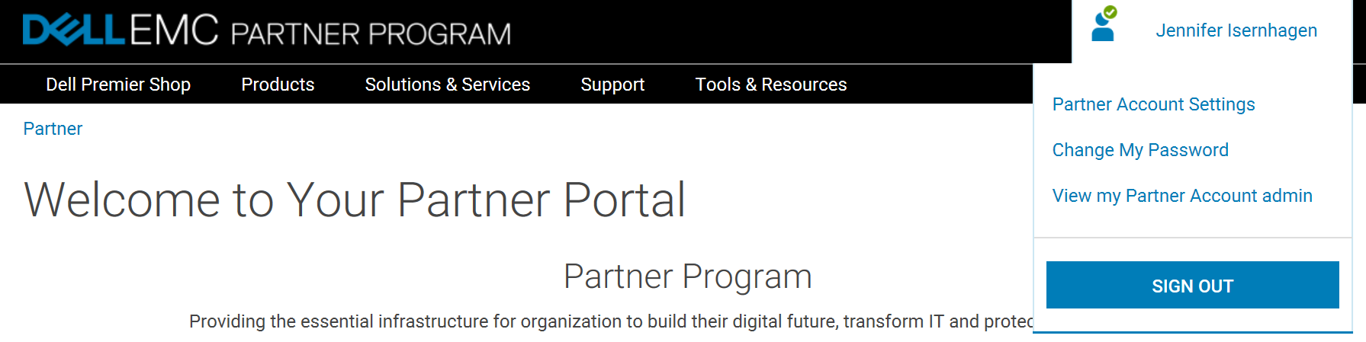

- Scroll to the bottom of the home page and click on the Partner Support tile. On the Partner Support page, click on the Dell Account Settings tile.
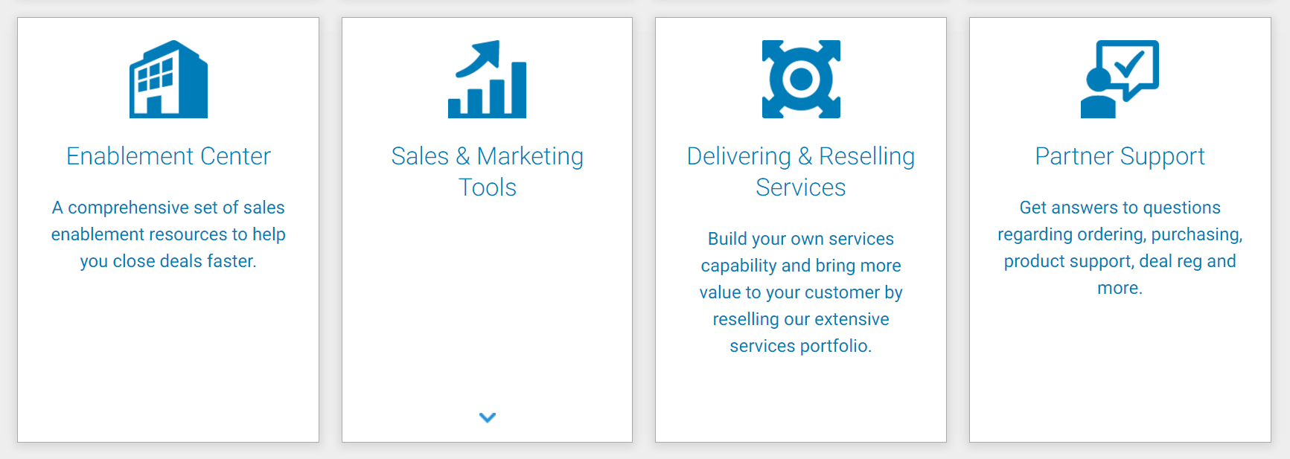
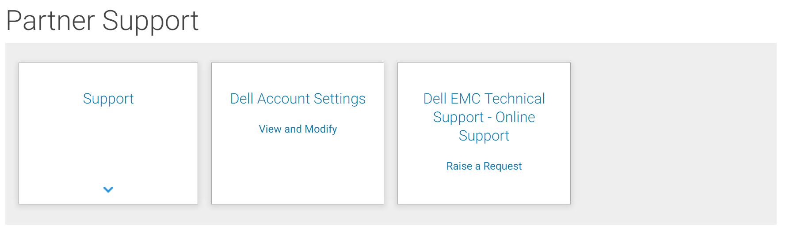
Manage My Company Information

Update/modify company details by selecting the appropriate link under Maintain my company Information.
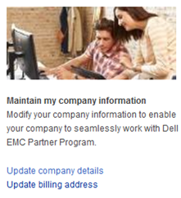
Users and Access

Manage Users and Access
Add new account contact, edit existing user profile settings, or revoke access from user using the links under Manage your account users and Manage users’ access to tools allows you to manage the access of a user to different tools available.
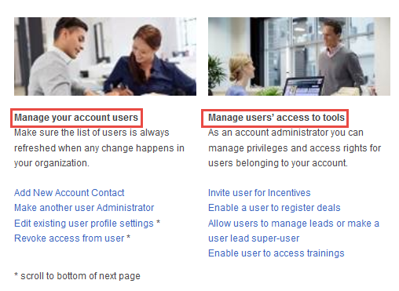

New User Profile

To create a new user login:
- From Manage your account users, click on “Add New Account Contact”
- Fill in the individual’s information. Please note, the fields marked in red are required.
- Click on the checkboxes to add specific functions
- Click on Save
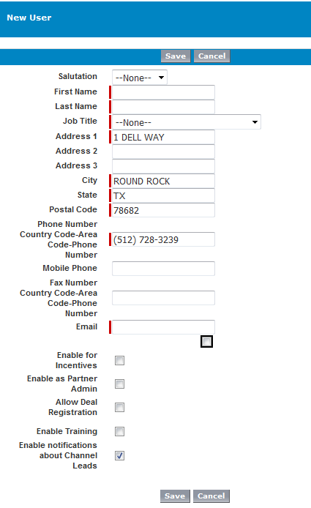

What happens next?
Once you successfully complete a new login, the contact will receive a welcome email with the portal
login information.
- Please note, it can take 30 minutes to 24 hours for a new login to become fully active.
- There may be short periods when the system is unable to set up a login. If you try to set up a login during that period, Dell’s system creates a work ticket and the Onboarding team will try to
manually complete the login within 1 business day.

Edit User Profile

From Manage your account users, click on “Edit existing user profile settings”. Or you can select a specific feature under Manage users’ access to tools (such as “Enable a user to register deals”, or “Enable user to access trainings”).
Once you have clicked on the appropriate link:
- Scroll to the bottom of the page (please note – use BOTH scroll bars)
- Find the user profile and click on edit
- Add the appropriate options and click save
Please note – Enable Training is no longer an active option. Access to training is handled automatically by the system.

Add Incentive Access to a User Profile

From Manage users’ access to tools, click on “Invite user for Incentives”. Look over the list to find a specific user or use the search feature on top of the page. Click on the box to the right of the user and click on the save button at the bottom of the page.
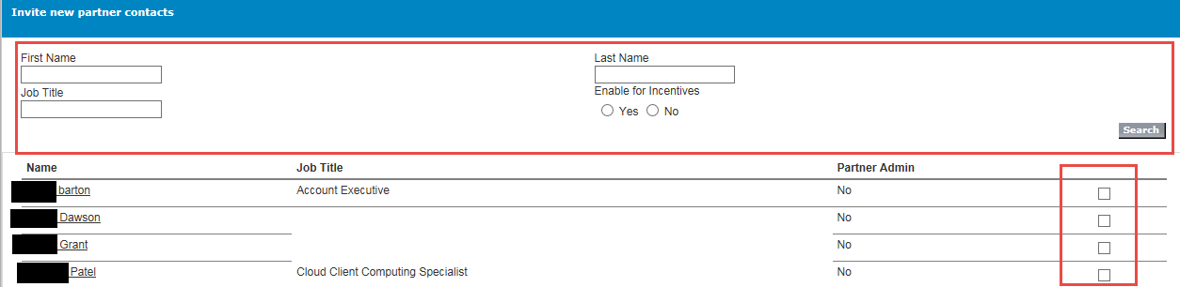
Deactivating a User

You should always deactivate any users that are no longer with your company.
TO DEACTIVATE A USER, PLEASE FOLLOW THESE INSTRUCTIONS CAREFULLY
- From Manage your account users, click on “Revoke access from user”
- Scroll to the bottom of the page (please note – use BOTH scroll bars)
- Find the user profile and click on edit
- Uncheck all option boxes
- Click on “Save”
- Then click on that Users’ “Inactivate” link
- Please confirm by clicking on Yes
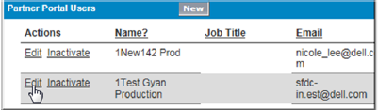
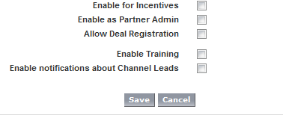
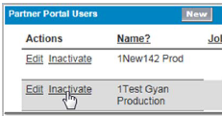
User Program Communication Preferences

Portal users can select communication preferences to recieve Dell EMC program information relevant to areas of interest and expertise. Settings can be updated under Account Settings menu.

Select Allow Dell EMC to send me communications.
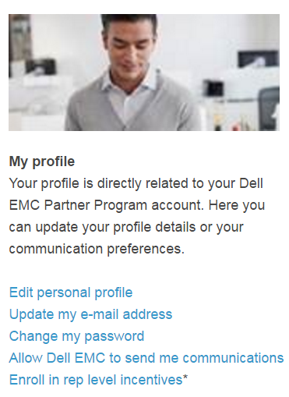

Check the box to accept the privacy statement enabling the user accont to recieve email communications regarding offers and announcements from Dell EMC. Users may unsubscribe at any time by using the ‘unsubscribe’ link at the bottom of any email communication.
Users can select areas of interest to receive program updates and news for training and competencies, marketing and specific lines of business.
- Choose the frequency of communications (upon publication, weekly, monthly)
- Add job-title to receive even more relevant information to your field of expertise
- Change your settings at any time
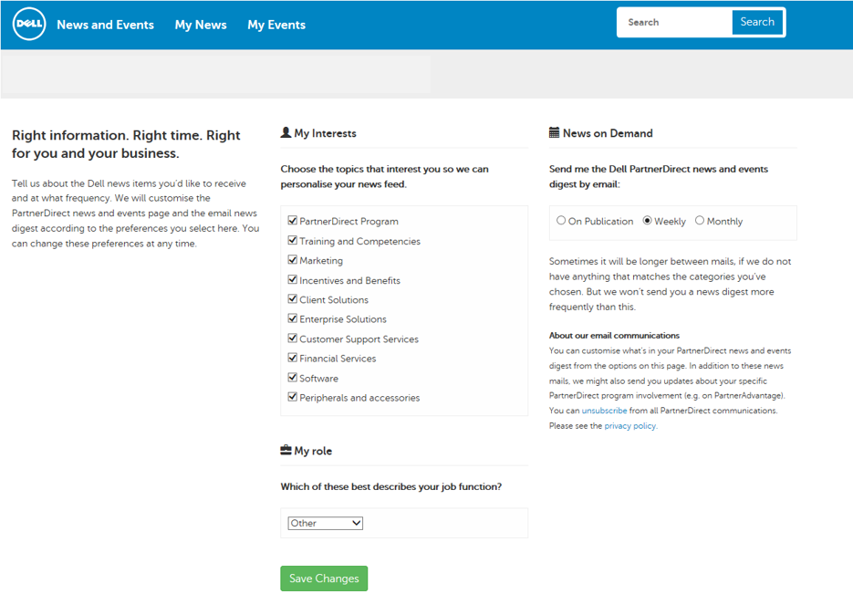
Partner Rebates

Since various rebate programs are updated every quarter, all eligible partners MUST access the rebate portal and accept the rebate program terms and conditions ONCE EVERY QUARTER. If a partner fails to accept the terms and conditions, they will not be eligible for those rebate programs the following quarter. Only approved primary contacts will be granted access to the Rebate Tool.
Partner Path to the Rebate Portal for Preferred and Premier Partners:
From the portal home page
- Click on the Incentives Tile
- Click on the Rebates Tile
- Click on ACCESS REBATES TOOL NOW link
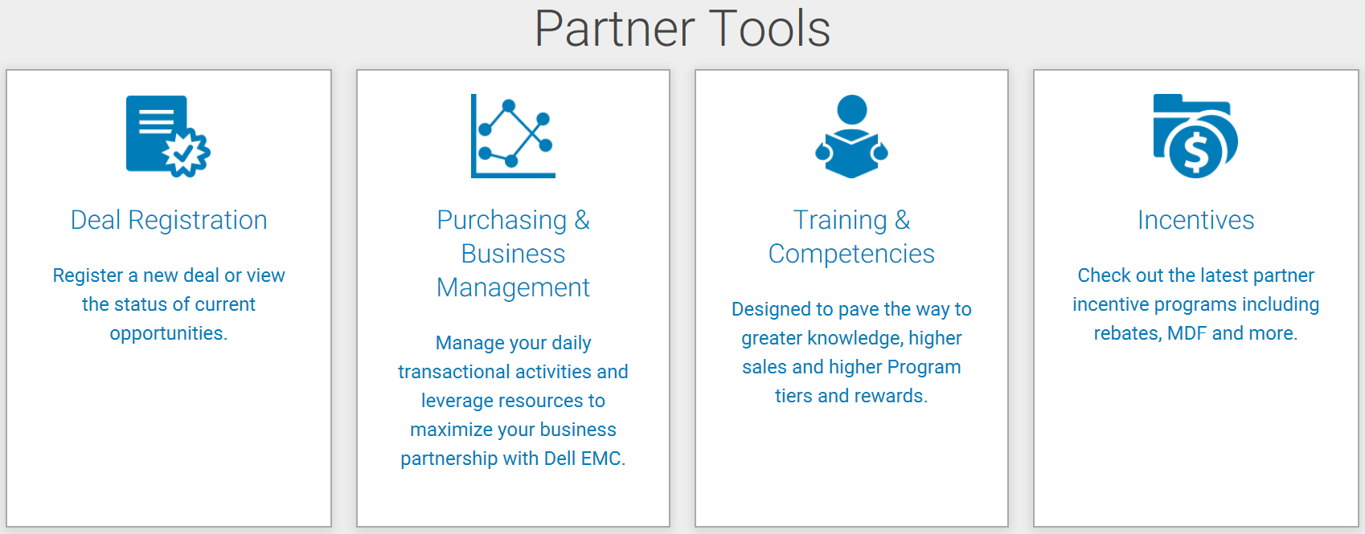

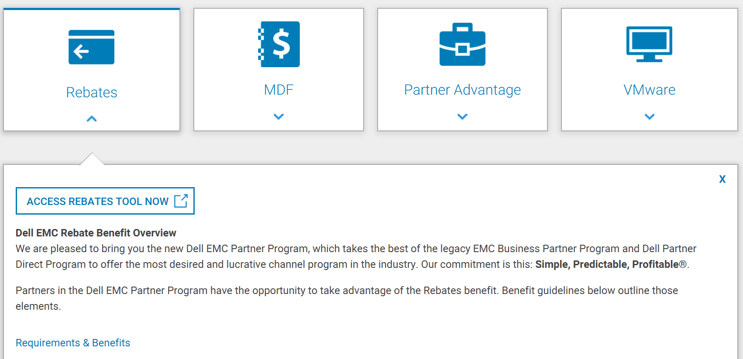

Accepting Dell EMC Partner Program Rebate terms and conditions.

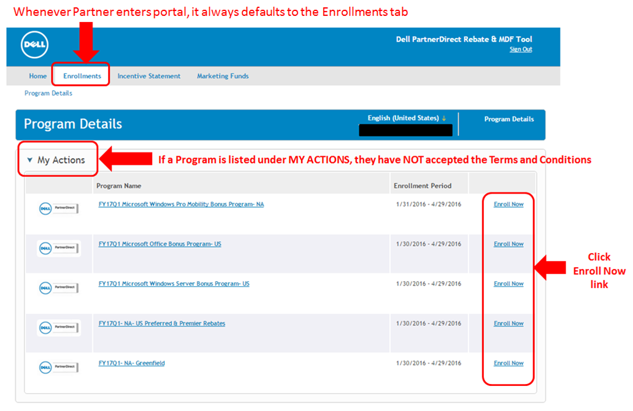
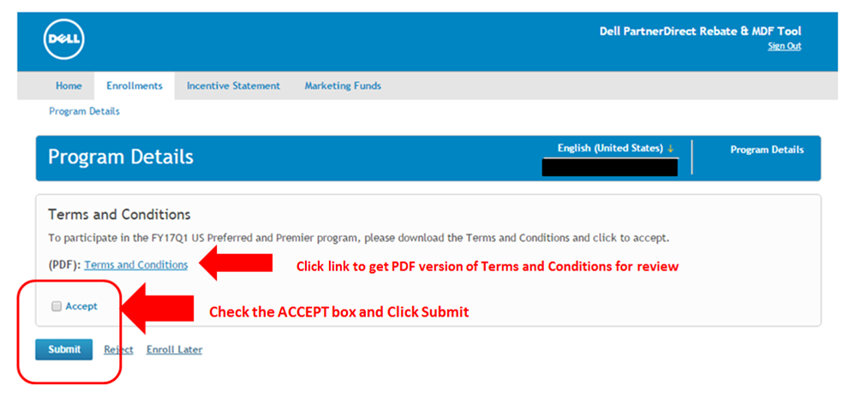
Find a Partner

Tiered Partners have the ability to list their organization on the Dell Find a Partner tool. Make sure your company can be found! Find a Partner is a great resource to help customers find your business. On the Account Setting page, you will find a section focused on the Find a Partner tool. From the “Create or Update your Find a Partner Profile,” you can manage your company contact information and add your company logo, overview, and description. There are links with more information regarding the tool and requirements in this section.
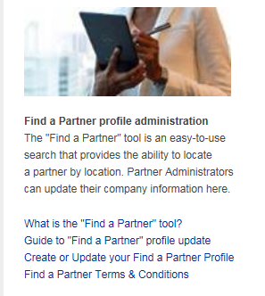
Additional Administrator Resources

Administrators have the ability to make most of the changes outlined in this document. For assistance, please contact one of the teams below:
US/CANADA
- To change a company admin contact PartnerDirect Onboarding at NA.DellEMC.PartnerOnboarding@Dell.com
- For questions regarding partner training, access to the rebate tool or about your Partner status contact Certified Partner Resource & Development at Certified_PRD@Dell.com
LATAM
- To change a company admin contact PartnerDirect Onboarding at LATAM_DellEMC_PartnerOnboarding@Dell.com
- For questions regarding partner training, access to the rebate tool, or about your Partner status contact Certified Resource & Development at LATAM_PartnerResourceDesk@Dell.com
EMEA
- To change a company admin contact PartnerDirect Onboarding at EMEA.DellEMC.PartnerOnboarding@Dell.com
- For questions regarding partner training, access to the rebate tool, or about your Partner status contact Certified Partner Resource & Development at EMEA_Certified_Partner_Program_Team@Dell.com
APJ
- To change a company admin contact PartnerDirect Onboarding at APJ.DellEMC.PartnerOnboarding@Dell.com
- For questions regarding partner training, access to the rebate tool, or about your Partner status contact APJ.DellEMC.PartnerOnboarding@Dell.com
- Certified Partner Resource & Development at Certifiedpartner_R@Dell.com

